**Redon, Odilon (1840-1816)**

Odilon Redon was a French painter, printmaker, draughtsman, etcher and pastellist. His capacity to master various materials and techniques has often left him associated with no single oeuvre or style in particular. Nevertheless, Redon is chiefly considered a key figure in the visual arts segment of Symbolism. His fierce rejection of realism, passionate endorsement of self-consciousness, and his interest in the relationship between image and text cemented Redon as a significant though often underestimated contributor to Modernism. Redon’s belief that images should function equally well with or without text established the artist as a provider of a new form of illustration, which operated as a sort of visual stimulant profounder than mere words. Furthermore, the Modernist tendency towards scrupulous and somewhat masochistic analyses of every aspect of existence, often manifested in aesthetic introspection, is clear in both Redon’s dreamy yet disturbing artwork and his journal entitled *À Soi-même* (1867-1915). His relationship with key French writers, such as Charles Baudelaire and Stéphane Mallarmé, and his production of increasingly surreal and abstract artwork resulted in his adoption by a plethora of Modernist movements, including Art Nouveau, Surrealism, Expressionism and Fauvism.

Redon’s childhood experiences can arguably account for the peculiarity of his vision. Deemed too withdrawn, Redon was abandoned by his family at infancy and sent to live on the dilapidated estate of Peyrelebade, in the feral landscape of the Médoc. Starved of affection, the young Redon immersed himself in the region’s ‘primitive’ culture and fascinating natural world. Although physically something of a prison, Peyrelebade proved a haven for introspective exploration. Redon returned as a young adult to his birthplace of Bordeaux, where he was instructed in lithography by Rodolphe Bresdin, and enlightened by the discoveries of botanist Armand Clavaud. He later relocated to Paris and produced his *noirs*, which comprised contemplative artworks conceived principally in charcoal and lithography. Redon’s early career is marked by these perplexing *noirs*, with his first album *Dans le Rêve* published in 1879, and his mockery of evolution, *Les Origines*,in 1883. Although he vehemently denied being guided by literature per se, Redon’s interest in major writers is irrefutable, having produced lithographic series dedicated to Edgar Allan Poe (1882), Gustave Flaubert (1888, 1889 and 1894) and Charles Baudelaire (1890).

The latter years of Redon’s career saw him favour pastels and oils. Opting to produce richly colourful masterpieces which incorporated the spiritual figure of the Buddha, he exhibited with the Nabis at Durand-Ruel in 1899. The evidence of both Japonisme and a wistfully abstract exploration of the psyche in Redon’s work resulted in his influencing Modernist movements around the world. Moreover, Redon’s legacy appears to be growing, demonstrated by the exhibition *Beyond the Visible* at the Museum of Modern Art in 2005, and the Fondation Beyeler’s retrospective in Basel in 2014, the latter almost 100 years after the artist’s death.

**References and further reading**

Eisenman, Stephen F. (1992), *The Temptation of Saint Redon: Biography, Ideology and Style in the Noirs of Odilon Redon.* Chicago: University of Chicago Press.

Gamboni, Dario (1989), *La plume et le pinceau: Odilon Redon et la littérature*. Paris: Editions de Minuit.

Hollein/Stuffmann, Max/Margret (eds.) (2007), *Odilon Redon: As In A Dream*. Stuttgart: Hatje Cantz.

Jacob/Wasserman, Mira/Jeanne L. (eds.) (1996), *To Myself: Notes on Life, Art, and Artists*. New York: George Braziller.

‘Lumière: Lithographs by Odilon Redon’, *The Fitzwilliam Museum,* University of Cambridge. <http://www.fitzmuseum.cam.ac.uk/gallery/redon/>

**Word Count: 561**

**Image information**

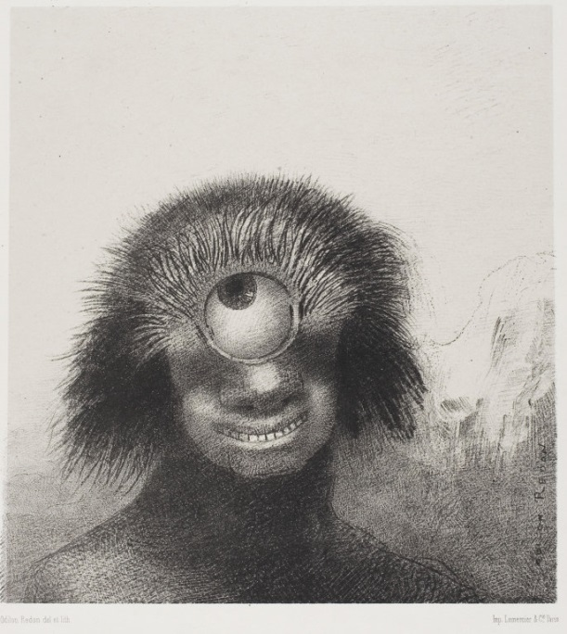

*The Misshapen Polyp Floated on the Shores, Sort of Smiling and Hideous Cyclops*

Plate 3 of 8 from *Les Origines*, 1883, Odilon Redon.

Lithograph, 213 x 200mm

The Stickney Collection, 1920. 1580

Mellerio 47 with letters; Werner 22

Art Institute of Chicago

<http://www.artic.edu/aic/collections/artwork/79347?search_no=6&index=54>